******Industrial Project Report**

*Submitted in partial fulfillment of the degree of*

**B-tech in Computer Science and Engineering**

**By**

***Bikki Prasad [11900121046]***

***Rohit Shrivastava [11900121059]***

***Chandni Kumari [11900121023]***

***Shuvam Mishra [11900121035 ]***

***Rishu Kumar Anal [19900121043]***

***Priyanshu Choudhary [11900121005]***

**Second-year student of**

**SILIGURI INSTITUTE OF TECHNOLOGY**

*THIS IS SUBMITTED IN FULFILLMENT OF THE REQUIREMENTS FOR THE DEGREE OF*

**AFFILIATED TO**

**Maulana Abul Kalam Azad University of Technology**

**Under the supervision of :-** Mr. Ripam Kundu

**Sikharthy Infotech Pvt. Ltd.**

***PROJECT ON :- Rock-Paper-Scissor WITH MACHINE LEARNING***

By

***Bikki Prasad [11900121046]***

***Rohit Shrivastava [11900121059]***

***Chandni Kumari [11900121023]***

***Shuvam Mishra [11900121035 ]***

***Rishu Kumar Anal [19900121043]***

***Priyanshu Choudhary [11900121005]***

UNDER THE GUIDANCE OF

**Mr. Ripam Kundu**

**Project Guide**

**Sikharthy Infotech Pvt. Ltd.**

*THIS IS SUBMITTED IN FULFILLMENT OF THE REQUIREMENTS FOR THE DEGREE OF*

**B.Tech**

IN

Computer Science and Engineering

**SILIGURI INSTITUTE OF TECHNOLOGY**

**AFFILIATED TO**

**Maulana Abul Kalam Azad University of Technology**

**Department of Computer Science and Engineering**

I hereby forward the documentation prepared under my supervision by **Ripam Kundu Sir** entitled **Siliguri Institute Of Technology** to be accepted as fulfillment of the requirement for the Degree of Bachelor of Technology in Computer ScienceandEngineering, **Siliguri Institute Of Technology** affiliated to **Maulana Abul Kalam Azad University of Technology** (**MAKAUT**).

|  |  |
| --- | --- |
| \_\_\_\_\_\_\_\_\_\_\_\_\_\_\_\_\_\_\_\_\_\_\_\_\_\_\_\_\_\_\_\_\_\_\_\_\_\_\_\_\_\_\_\_\_\_\_\_\_\_\_\_    **Mr.Ripam Kundu**  **(Software Developer)**  **Project Guide**  **Sikharthy Infotech Pvt. Ltd.**  **Shilpi Ghosal**  **(Director)**  **Sikharthy Infotech Pvt. Ltd.** | \_\_\_\_\_\_\_\_\_\_\_\_\_\_\_\_\_\_\_\_\_\_\_\_\_\_\_\_\_\_\_\_\_\_\_\_\_\_\_\_\_\_\_\_\_\_\_\_\_\_\_\_    **HOD**  **Department Of Computer Science and Engineering, SIT** |

**TPO**

**Siliguri Institute of Technology**

**Certificate of Approval**

The foregoing project is hereby approved as a creditable study for the B.Tech inComputer Science and Engineering presented in a manner of satisfactory to warrant its acceptance as a prerequisite to the degree for which it has been submitted. It is understood that by this approval the undersigned do not necessarily endorsed or approved any statement made, opinion expressed or conclusion therein but approve this project only for the purpose for which it is submitted.

Final Examination for

Evaluation of the Project ----------------------------------------

-----------------------------------------

------------------------------------------

**Signatures of Examiners**

**ABSTRACT**

*The paper explains the working of an Rock-Paper-Scissor, The computer keeps track of the conditional probabilities of you picking each of the three objects given the object you picked last. The computer always picks the object that beats the one that it thinks you are most likely to choose. Although it knows what you have actually picked (you press one of the buttons to make your choice), it is honest and doesn't cheat!*

*You can observe the computer learning by picking a strategy and sticking to it for a while. Here are a few things to try:*

*Pick Rock, then Paper, then Scissors, then Rock again and keep that pattern up. See how quickly the computer learns to beat you every time?*

*Having done that a few times, change strategy and pick Paper 5 times in a row. See how the computer spots your change of strategy and alters its play?*

*Pick any strategy of your own and see if the computer can spot the pattern.*

*See if you can be perfectly random in your choices and beat the computer*

**ACKNOWLEDGEMENT**

It is a great pleasure for me to acknowledge the assistance and participation of a large number of individuals in this attempt. Our project report has been structured under the valued suggestion, support, and guidance of **Mr. Ripam Kundu**. Under his guidance, we have accomplished the challenging task in a very short time.

Finally, we express our sincere thankfulness to our family members for inspiring me all throughout and always encouraging us.

**Group Mamber Signature**

**TABLE OF CONTENTS**

* Introduction 8
* Importing Dataset 8
* Data Profiling 9-10
* Data Pre-processing 10
* Data Visualization 11
* Code & Screenshot
* Conclusion

**INTRODUCTION**

 We will use [Python](https://www.geeksforgeeks.org/python-programming-language/) and its different libraries to complete the Rock-Paper-Scissor

**WHAT LIBRARIES WE USED**

## **Importing Libraries**

The analysis will be done using the following libraries :

**TensorFlow** is a free and open-source software library for machine learning and artificial intelligence. It can be used across a range of tasks but has a particular focus on training and inference of deep neural networks.

**NumPy** is a Python library used for working with arrays.It also has functions for working in domain of linear algebra, fourier transform, and matrices.NumPy was created in 2005 by Travis Oliphant. It is an open source project and you can use it freely.NumPy stands for Numerical Python.

**OpenCV** is a library of programming functions mainly for real-time computer vision. Originally developed by Intel, it was later supported by Willow Garage, then Itseez. The library is cross-platform and licensed as free and open-source software under Apache License

To importing all these libraries, we can use the  below code :

|  |
| --- |
| **import tensorflow as tf**  **import numpy as np**  **import cv2**  **import random** |

## **Importing Dataset**

After importing all the libraries , you can import the dataset using the PIL library.

|  |
| --- |
| Capturer |

**So after importing the images the output we get is : -**

**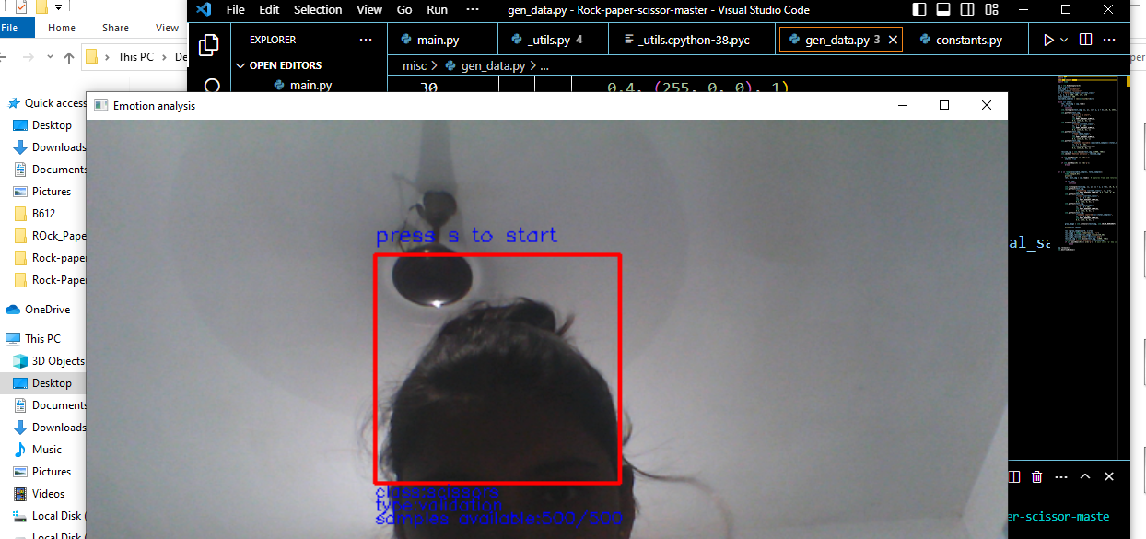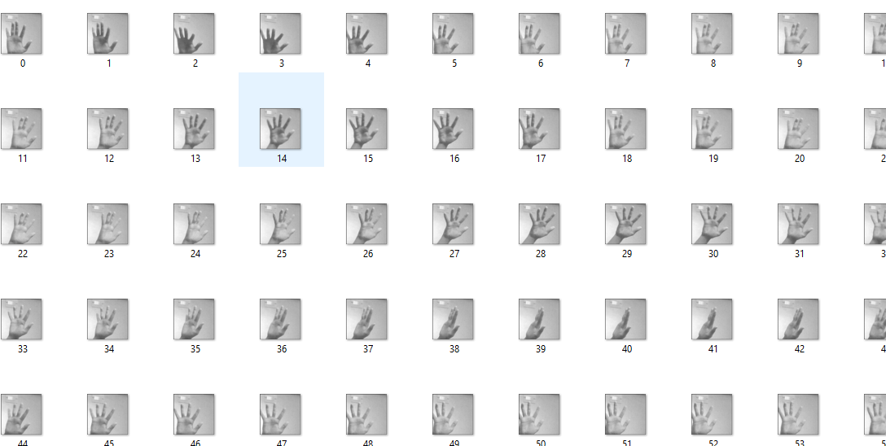**

**Empty C:\Users\Dell\Desktop\Rock-paper-scissor-master\data\train\empty**

**Rock C:\Users\Dell\Desktop\Rock-paper-scissor-master\data\train\rock**

**Paper C:\Users\Dell\Desktop\Rock-paper-scissor-master\data\train\paper**

**scissor C:\Users\Dell\Desktop\Rock-paper-scissor-master\data\train\scissors**

**DATA PROFILING:-**

**Data profiling is a technique used to analyse and gain a better understanding of raw data. It is the first step in determining what**[**insights**](https://www.datarobot.com/wiki/insights/)**data can yield when you run it through**[**machine learning**](https://www.datarobot.com/wiki/machine-learning/)[**algorithms**](https://www.datarobot.com/wiki/algorithm/)**in order to make**[**predictions**](https://www.datarobot.com/wiki/prediction/)**. Through data profiling, you determine whether the dataset is complete and accurate enough to solve a practical business problem. It is the very first step in**[**preparing**](https://www.datarobot.com/wiki/data-preparation/)**your data for predictive analytics, and it is essential for clarifying the structure, content (**[**features**](https://www.datarobot.com/wiki/feature/)**), and relationships of your dataset for predictive [modeling](https://www.datarobot.com/wiki/model/" \t "_blank).**

**In the Data Profiling section , we were able to take out the output of the webcam adapting dataset.**

**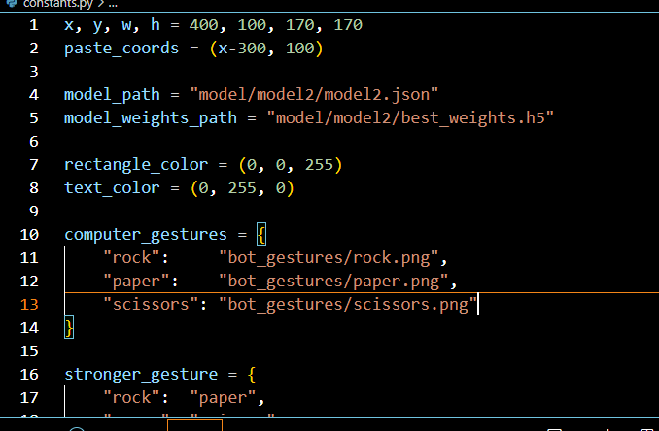**

**DATA PREPROCESSING :-**

**Data pre-processing is a process of preparing the raw data and making it suitable for a machine learning model. It is the first and crucial step while creating a machine learning model.When creating a machine learning project, it is not always a case that we come across the clean and formatted data. And while doing any operation with data, it is mandatory to clean it and put in a formatted way. So for this, we use data pre-processing task.**

The [ParallelImageDataGenerator](https://siliconlabs.github.io/mltk/docs/python_api/data_preprocessing/image_data_generator.html) also features some data preprocessing settings:

samplewise\_center**=True**samplewise\_std\_normalization**=True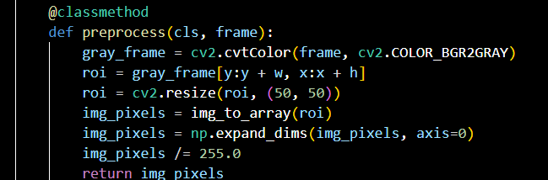**

This helps to ensure the model is not as dependent on camera and lighting variations.

**DATA VISUALISATION :-**

**Data visualization is the graphical representation of information and data. By using v**[**isual elements like charts, graphs, and maps**](https://www.tableau.com/data-insights/reference-library/visual-analytics)**, data visualization tools provide an accessible way to see and understand trends, outliers, and patterns in data. Additionally, it provides an excellent way for employees or business owners to present data to non-technical audiences without confusion.**

**In the world of Big Data, data visualization tools and technologies are essential to analyze massive amounts of information and make data-driven decisions**.

**INPUT :-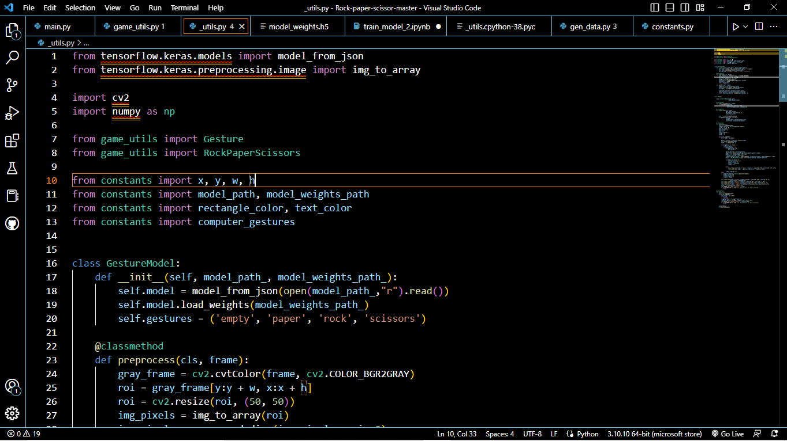**

**USER INTERFACE OUTPUT:**

**Input**

**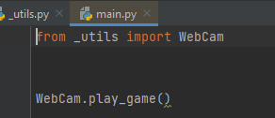**

**output**

**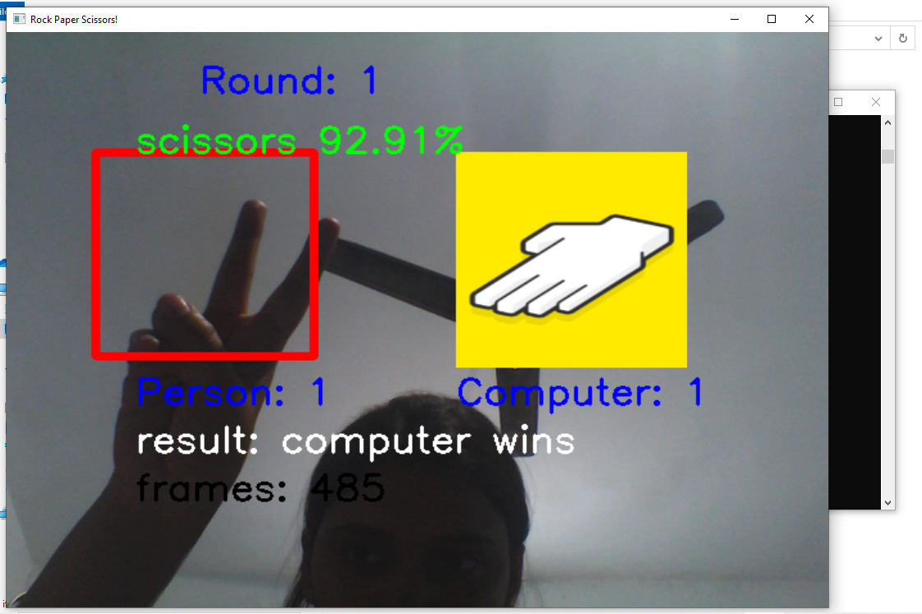**

**FUNCTIONAL REQUIREMENTS OF THE SYSTEM**

***SOFTWARE:***

* *Operating System*
* Windows OS 11

***WEB BROWSER:***

* Internet Explorer 7
* Google Chrome

***CODING LANGUAGE :***

* Python

**Conclusion :**

We’ve successfully implemented and understood the workings of this project. A major improvement would probably be adding hand detection so we don’t need to explicitly draw a target zone and model would first detect hand position then make a prediction. we’ve tried to keep our language as beginner-friendly as possible ,we now know how to create rock paper scissors from scratch, and we’re able to expand the number of possible actions in our game with minimal effort.

**REFERENCE**

<https://siliconlabs.github.io/mltk/mltk/tutorials/image_classification.html>

[**https://www.youtube.com/watch?v=4GQYawzWKNo&feature=youtu.be**](https://www.youtube.com/watch?v=4GQYawzWKNo&feature=youtu.be)

**https://www.geeksforgeeks.org/python-program-implement-rock-paper-scissor-game/**